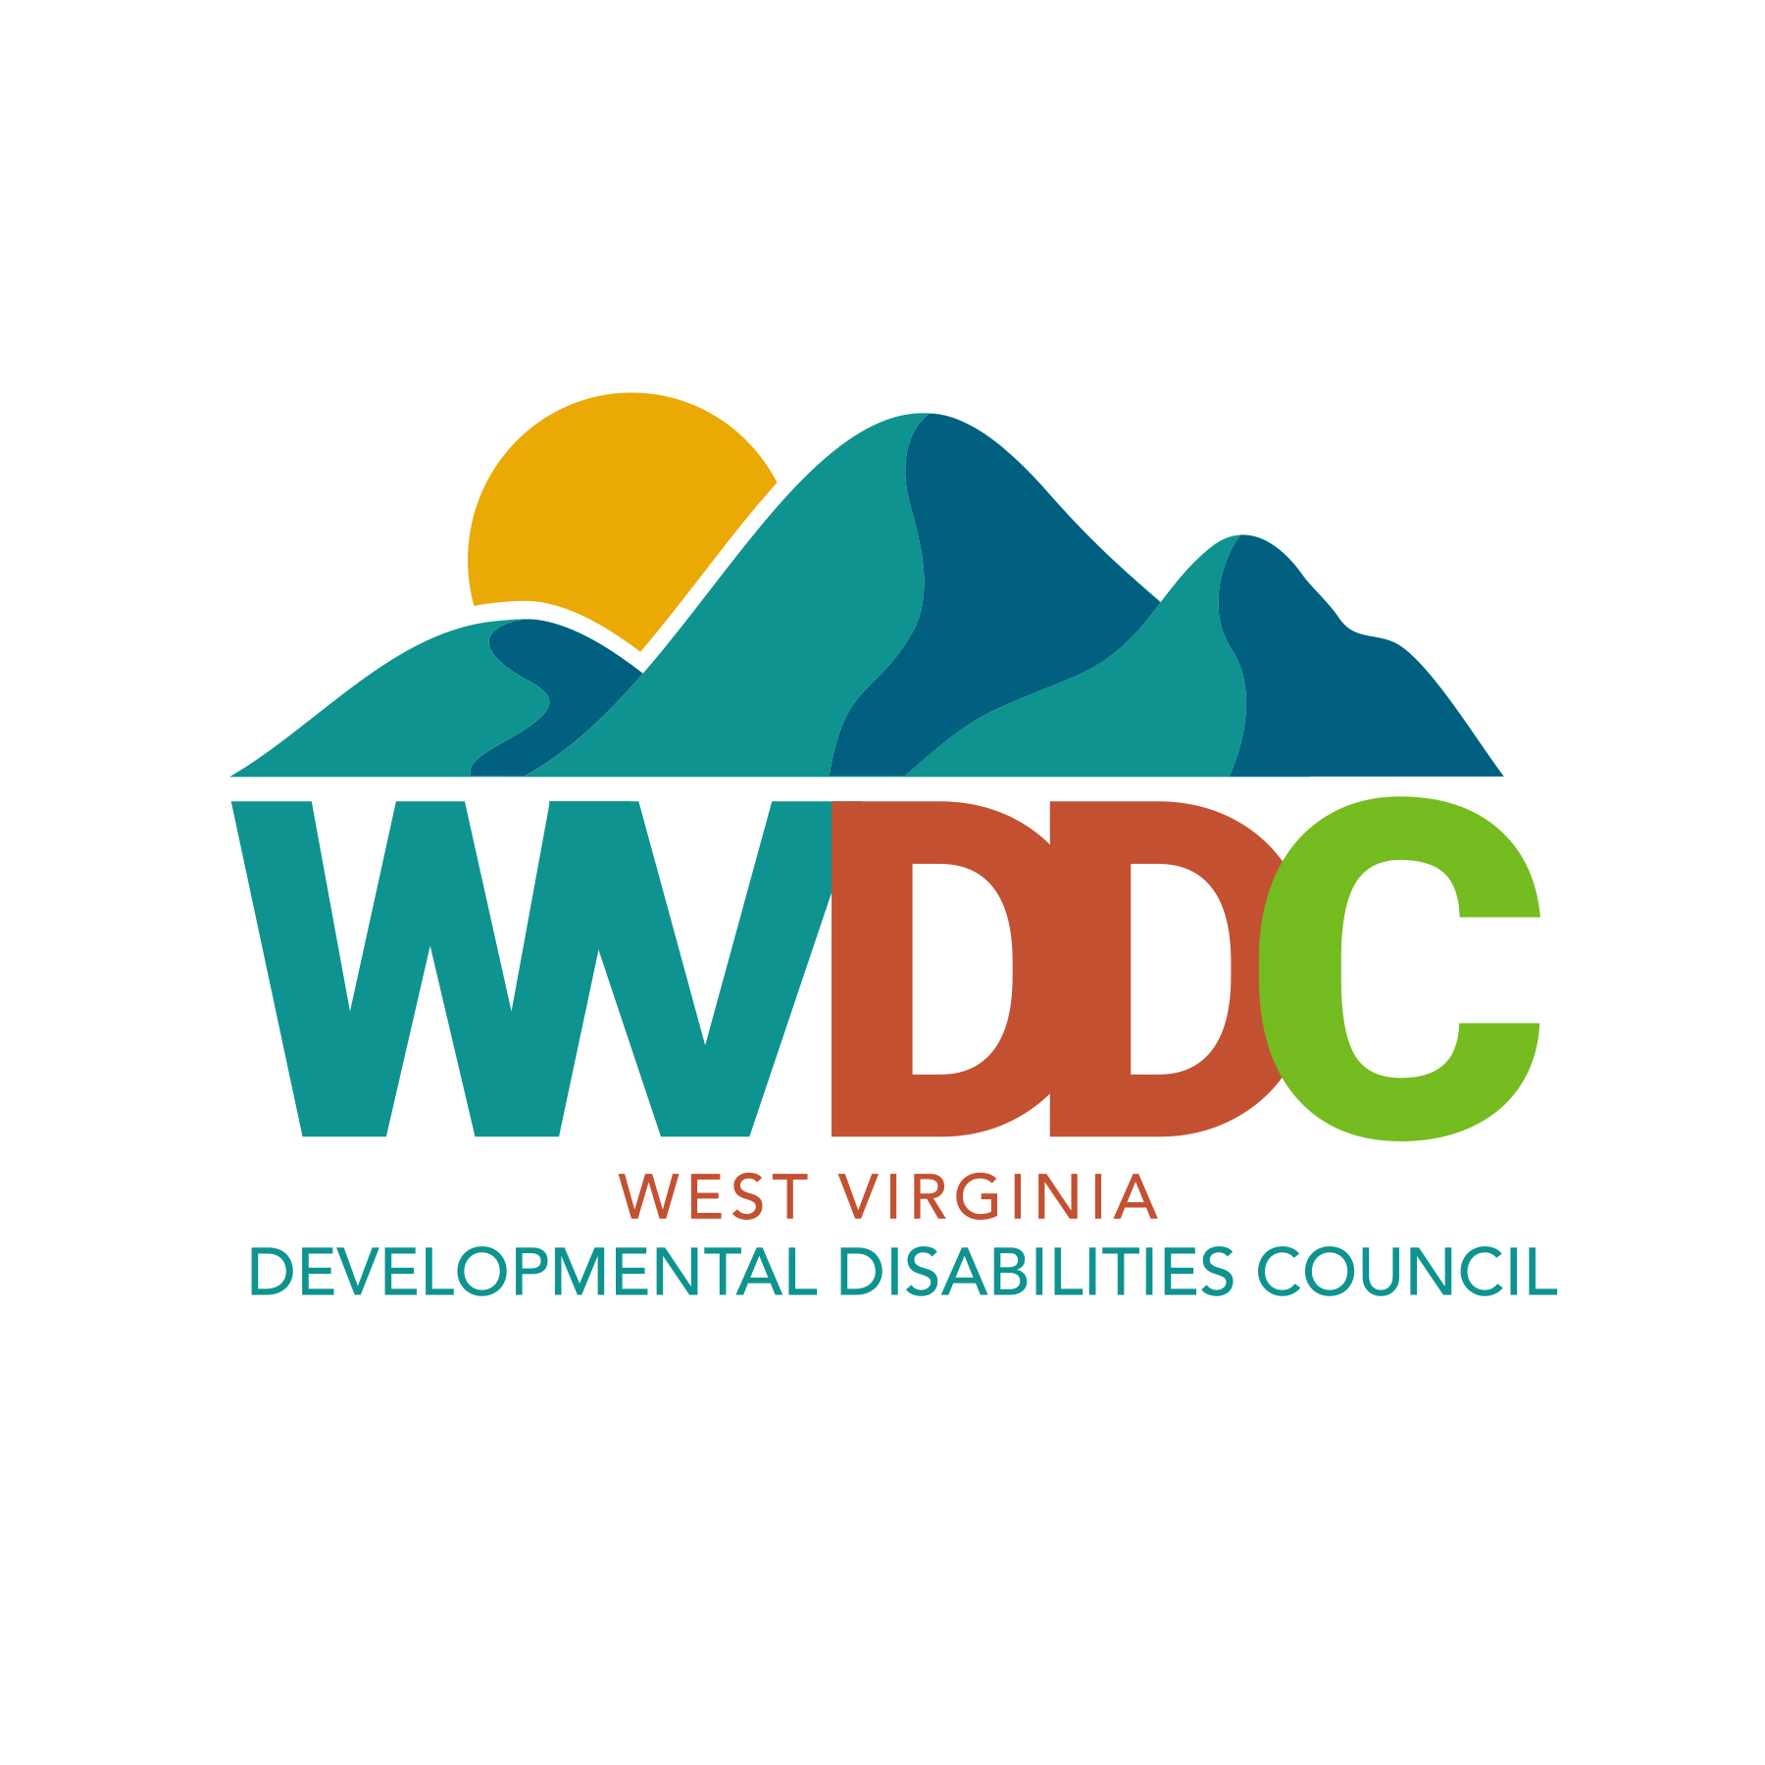 | WV Developmental Disabilities Council  Quarterly Meeting Minutes  April 23, 2024

Members present: Kenneth Accord, Brandy Beery, Steve Brady, Carissa Davis, Tonya Eve, Rose Fair, Lynsay Frye, JaQue Galloway, Amber Moore, Jeffery Pack, Tonya Rutkowski, Charlotte Roth, and Anna Smith

Members present (virtually): Stacy Broce (for Randy Hill), Susan Given, Tracy Hartnett, Kim Hawkins, Samantha Matos, and Jacqueline Proctor

Members absent: Rhonda Blosser, Janice Bostic, Cynthia Brockman, Lesley Cottrell, Jennifer Dotson, Marc Ellison, James Gallaher, Richard Hammons, Randy Hill, Susan Loudermilk, Paulette Southerly, Marsha Spiker, Ashley Stewart, Jessica Sykes, and Mel Woodcock

Staff present: Katie Arbaugh, Christy Black, and Tina Wiseman

Guest(s): Steve Wiseman (presenting with Carissa Davis for the Olmstead State Plan Update Forum)

Call to Order & Welcome: Brandy called the meeting to order and went over the packets.

Introductions & Announcements: Brandy welcomed everyone and asked for introductions.

Mission Statement:
Rose Fair read the mission statement.

OLD BUSINESS
Approval of January 23, 2024 Meeting Minutes: Tonya Eve moved, and Charlotte Roth seconded the motion to approve the Minutes. There was no discussion. Motion carried with no nays or abstentions.

NEW BUSINESS
Election of New Members: Tonya Eve presented the Nominating Committee report. The Council has 13 vacancies for Council Members. The Nominating Committee presented 12 names for membership. The Nominating Committee will continue to work to fill one vacancy for a Member who has lived institutional experience (DD Act requirement). The Nominating Committee would like to recommend Kim Hawkins and Jessica Sykes for a second term. In addition, the Nominating Committee would like to recommend: Stephen Barr, a person with a developmental disability; Rachel Brown, a parent of a person with a developmental disability; Vanessa Combs, parent of a person with a developmental disability; Christen Dougherty, a person with a developmental disability; Jacquelyn Erb, a parent of a person with a developmental disability; Darla Ervin, a person with a developmental disability; Sheri Mills, a parent with a person with a developmental disability, Lydia Milnes, at-large member; Cara Price, a parent of a person with a disability; and Shawn Allen, a parent of a person with a developmental disability.

Tonya Eve moved, and Charlotte Roth seconded the motion to approve the slate of members. There was no discussion. Motion carried with no nays and one abstention from Kim Hawkins.

Review and Approve Updated Policies: Tina Wiseman reviewed the amendments to the Policy on Membership and Meetings. Charlotte Roth moved, and Rose Fair seconded the motion to approve the updated Policy on Membership and Meetings. There was no discussion. Motion carried with no nays or abstentions.

Tina reviewed the amendments to the Policy on People First and Identity First Language. Lynsay Frye moved, and Anna Smith seconded the motion to approve the updated Policy on People First and Identity First Language. There was no discussion. Motion carried with no nays or abstentions.

COUNCIL UPDATES:
Legislative Wrap Up: Christy Black gave a wrap up report on the 2024 WV Legislative session. Education bills seemed to dominate the session this year. She reported that many of the budget items were level funded with the exception of several of the line items for the Department of Human Services which received a ten percent cut. The line item for the IDD Waiver was slashed by ten percent, and this would equate to $11 million in state funds, and $33 million in federal match.

Christy discussed HB 5157 and an amendment to the budget in the House that would have added a MCO tax to assist with being able to give direct care workers a higher reimbursement rate. The legislature stated that they needed a skinny budget in case they had to pay back money to the US Department of Education due to issues with ARPA funds for Education. The Governor stated that he planned to call a special session in May to put the money back if the State received a waiver for the $465 million. The state received this same waiver last year. Families, advocates, and providers held a rally to educate lawmakers about the IDD waiver program, the barriers, and why the funding should be restored. Hundreds of people attended the rally on April 14, 2024.

Christy stated that HB 4408 would allow the development of a specialized intermediate care facility for individuals with intellectual and developmental disabilities. This bill was not taken up by the Senate Health Committee thanks to advocates from the Council and our sister agency, DRWV. The Council opposed this bill. This bill would not have the intended outcome it attempts to achieve. The current ICF/IID moratorium law is based on a 1989 Hartley Court Order. In addition, the court ordered moratorium does not apply to the replacement of existing ICF/IID beds. Therefore, there is no need to create a new law related to this issue. Christy stated that there are approximately 70 vacancies in ICF/IID facilities due to staffing shortages and wages, and people continue to not choose ICF/IID facilities. Furthermore, in 2018 the legislature passed SB575 to add six four-bed ICF/IID facilities to address the need to serve people who were stuck in Sharpe and Bateman hospitals. These facilities are not being used today, and most were never built. Another case in point as to why we do not need any more institutional beds is what happened at Hopemont Hospital, a state run long term care facility, where an elderly nonverbal gentleman was put in a whirlpool with a faulty thermometer in 134 degree for 47 minutes which cost him his life.

Other bills Christy discussed were the education bills. They were HB 5158, HB 5262, and SB 614. All three of these bills were intertwined. The two house bills passed, but the senate bill failed when time ran out on the last day. The purpose of HB 5158 is to clean up statutory provisions regarding the special education code. One negative change made in this bill will make general education teachers not responsible for daily accommodation logs. The general education teacher shall only be responsible for acknowledging, at the end of each grading period, that each accommodation as required by the IEP has been met. The purpose of HB 5262 is to establish the creation of a Teachers Bill of Rights. The bill defines the duties of counselors and data to be provided. In addition, the bill defines the special education student to instructor ratio, a waiver process, and compensation given to a teacher when the ratio is exceeded. This bill also permits the removal of students from a classroom. The purpose of SB 614 was to address elementary behavior intervention and safety. This was known as the discipline bill. This bill allowed schools to send disruptive elementary students home in the back of a police cruiser if they could not reach the parents. This bill failed, but there has been talks about it being added to the special session in May.

Executive Director Update: Tina Wiseman reviewed the schedule for policy updates for the remaining year. She then reviewed and discussed the meeting feedback from the January meeting. Tina discussed attendance of Council members and solutions for improving attendance at meetings either virtually or in person. She also discussed solutions for the delay in the grants process.

Upcoming Events and Activities: Katie Arbaugh gave an update on the Transitions training in the Eastern Panhandle which was well received. She also discussed an upcoming training event at Stonewall Resort in June. Katie discussed the annual Work Plan and the upcoming process for the five-year State Plan.

2024 Disability Policy Seminar: Council members reported about attending Disability Policy Seminar. Rose Fair discussed her experiences. One of the sessions she attended discussed prisoners with disabilities being held for long periods of time in solitary confinement, and new legislation proposes that prisoners with disabilities cannot be held more than four hours at a time in solitary confinement. She also attended a session on how to tell your story which she found very helpful when she met with members of Congress.

Anna Smith stated said she met with Congresswoman Miller and Senator Manchin’s office and discussed DD Councils and home and community-based services. Lynsay Frye said that this was her second time attending. She learned a lot, in particular how police officers need training on how to work with people who are nonverbal. Brandy Beery said she enjoyed the seminar, and what an amazing group of advocates we had in our Council delegation. Brandy stated that in her delegation they focused on fully funding IDEA, Autism CARES act, and appropriations. She stated there were a lot of topics to cover in a short time. Congress members and staff asked several questions, and everyone brought something to the table.

State Agency Updates:
Bureau of Social Services: Amber Moore gave an update on behalf of the Bureau of Social Services. Budget cuts are their biggest concern. The Bureau is starting a commercial campaign to recruit adult family care services providers across the state. If you know anyone who may be interested tell them to go to their website for more information on how to get involved with the program.

Department of Education: Tonya Rutkowski gave an update on behalf of the Office of Special Education. Tonya stated that their SPP/APR annual report was due in February, and they are now in the clarification period with the US Department of Education. The draft will be posted on their website in June. Tonya also discussed the Transition training event to support both educators and families of students with disabilities preparing to go through transition to adulthood. The Department will also be presenting on behavior at the INVEST conference. They will also be holding a data literacy summit to help train teachers on how to report data and use the data to drive instruction. They will also be revising dispute resolutions in accordance with new legislation, and will be going to a new web platform that is more user friendly soon.

Bureau of Senior Services: Deputy Commissioner Proctor gave an update on behalf of the Bureau of Senior Services. She said BOSS is working on their state plan. They are reviewing new guidelines from ACL to make sure they are meeting these new requirements. She stated new Commissioner Worley has hit the ground running. She has a background in assisted living. The Bureau is sponsoring a Senior Conference at Cedar Lakes in Ripley, WV on May 21-23, 2024.

Division of Rehabilitation: Marsha Spiker was not in attendance, and we will add to the agenda for the July meeting.

Coming Home. An On the Outside project: The “On the Outside” grant project showed the film “Coming Home” during lunch.

Olmstead State Plan Forum: Carissa Davis, Olmstead Coordinator and Steve Wiseman, Facilitator broke up the Membership into 3 groups to brainstorm three questions. The groups reported out on their suggestions on amending the Olmstead State Plan.

Public Comment: There was no public comment given.

Members’ Comments/Concerns: There were no comments or concerns noted.

Completion of Feedback Forms: Members were asked to complete the feedback forms. Members attending virtually received the feedback form prior to the meeting, however, it will be re-sent to them.

Adjournment: Tonya Rutkowski moved to adjourn, and Steve Brady seconded the motion. Meeting adjourned.

